**Power Bi Project - Sales Dashboard**

**Objective:**

**To contribute to the success of a business by utilizing data analysis techniques, specifically focusing on time series analysis, to provide valuable insights and accurate sales forecasting.**

**Descriptions:**

**1. Dashboard Creation: Identify the KPIs, design an intuitive and visually appealing dashboard, add interactive visualizations and filtering capabilities to allow users to explore the data at various levels of granularity.**

**2. Data Analysis: Provide valuable insights to business entities regarding the effectiveness of their sales strategies through visualization and charts.**

**3. Sales Forecasting: Leverage historic data and apply time series analysis to generate sales forecasts for next 15 days.**

**4. Actionable Insights and Recommendations: End goal is to share valuable insights and actionable information that can drive strategic decisions support the supermarket’s goals for growth , efficiency, satisfaction.**

1. **Data cleaning**
2. **DAX (Data Analysis Expression) Queries**
3. **Dashboard**
4. **KPIs (Key Performance Indicator)**
5. **Forecasting**
6. **Insight**

**Note:**

**1. Apply filter in Excel – select column 🡪 ctrl+shift+L**

**2. Replace value in Excel – select column 🡪 ctrl+F**

**DAX Query:**

**1.** Average Delivery = **DATEDIFF**('SuperStore_Sales_Dataset'[Order Date],'SuperStore_Sales_Dataset'[Ship Date],DAY)

**Forecasting:**

**1. Forecasting is created through Line Chart.**

**2. Forecasting is based on time series.**

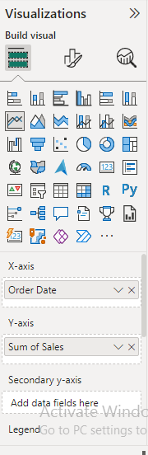 **Exp: column name 🡪 order_date**

**3.**

**Add Further Analysis To your future**

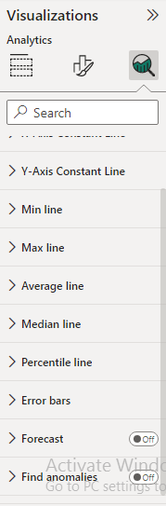

**4.**

Click ON

**Create a Table Forecasting:**

**Step -1: You will go to Table tools tab 🡪 You have to create a New table**

**DAX FORMULA:**

Forecast =

SUMMARIZE('Table_Name, groupBy_ColumnName,"Create a Column name" ,SUM(Column_name))

SUMMARIZE('SuperStore_Sales_Dataset','SuperStore_Sales_Dataset'[Order Date],"Total Sales",SUM(SuperStore_Sales_Dataset[Sales]))

**INSIGHT:**

**Incorporated data analysis techniques , specializing in time series analysis, to deliver valuable insights , accurate sales forecasting and interactive dashboard creation , driving business school.**